System Design Specification
Functional design for the CERA Medical ecommerce, service-content and blog platform
SYSTEM OBJECTIVE Create one maintainable digital platform that sells products, publishes service-led educational content, supports routine ecommerce operations, and gives CERA staff controlled administration without developer intervention for normal content and order work.

1. Scope boundary
- Public website with homepage, shop, product detail pages, service pages, blog, about/contact and legal pages.
- Full ecommerce foundation: catalogue, variants, inventory, cart, checkout, shipping, payment/COD, orders, promotions and customer history.
- Blog and service CMS with authors, categories, tags, media, SEO metadata, draft/review/publish state and related-content relationships.
- Admin access controls, transactional email, staff email, analytics, monitoring, backups and production deployment.
- Simple service conversion through contact/WhatsApp/action CTAs; no research opportunity pipeline or research-specific CRM workflow.

2. Actors and roles
Actor | Primary actions | System boundary
Visitor | Browse products, services and blogs; search; contact CERA. | Public website
Customer | Cart, checkout, account/order history where enabled, reorder, reviews if enabled. | Storefront + Vendure
Owner / Super Admin | Configuration visibility, user governance, operational overview. | Protected admin
Ecommerce Manager | Products, pricing, stock, promotions, orders and fulfilment. | Vendure Admin
Content Editor | Blogs, service pages, authors, media, metadata and scheduled publishing. | Payload Admin
Compliance / Scientific Reviewer | Review health/scientific wording before publish where required. | Payload workflow
Customer Support | View orders/customer context and resolve service issues within granted permissions. | Vendure Admin

3. System context
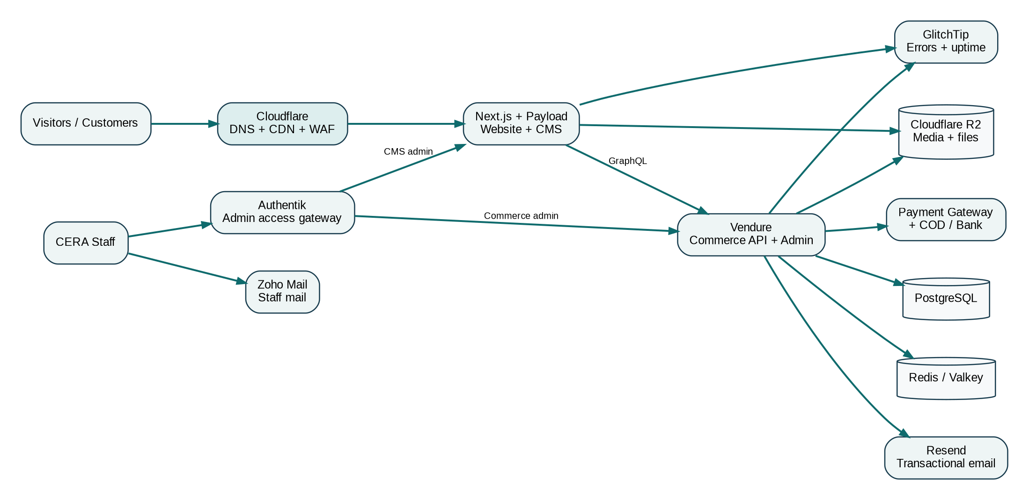
Figure 1. CERA platform system context

4. Functional modules
Module | Core responsibilities
Storefront | SSR/SEO pages, navigation, product discovery, services, blog, cart/checkout UI, contact/WhatsApp CTAs.
Commerce | Products, variants, pricing, tax/shipping rules, stock, cart, order lifecycle, promotions, customers, payment integrations.
Content CMS | Blog articles, service pages, authors, categories/tags, site settings, legal pages, media metadata and SEO controls.
Identity & access | MFA/SSO gateway for staff admin hosts, least-privilege roles, recovery and access revocation.
Media/storage | Product/blog/service media in R2; signed/private access for non-public objects; lifecycle controls.
Messaging | Order/account lifecycle email through Resend; human correspondence through Zoho Mail.
Observability | Error tracking, performance/uptime signals, structured logs and operational alerts.
Analytics/SEO | GA4/GTM, Search Console, Clarity, sitemap, structured data, canonical metadata and conversion events.

5. Commerce flow
Figure 2. Core purchase lifecycle

6. Content publishing flow
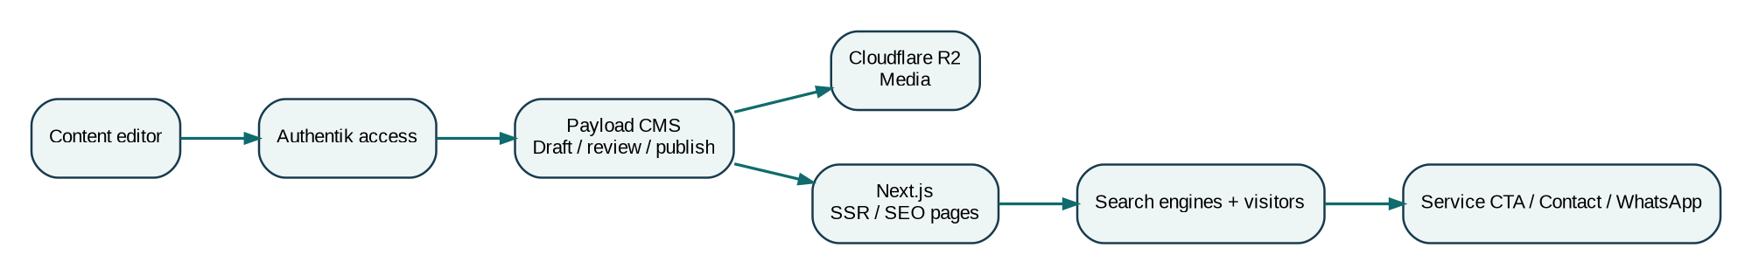
Figure 3. Service/blog publishing lifecycle

7. Core data entities
Domain | Entities / relationships
Commerce | Product -> Variant -> Stock; Customer -> Address; Cart -> Line Items; Order -> Payment/Shipping/Fulfilment; Promotion -> Conditions/Actions.
CMS | Article -> Author/Category/Tags/Related Service; Service -> Related Articles/CTA; Page -> Content Blocks; Media -> R2 object + metadata; Site Settings -> navigation/footer/default SEO.
Identity | Staff identity -> group/role -> protected admin surface; application-level role -> allowed actions.
Audit/ops | Admin action, login/security event, deployment, backup result, error/incident event.

8. Non-functional requirements
- Public product, service and article pages must be server-rendered or pre-rendered for SEO and resilience.
- Admin surfaces must not be publicly discoverable without access controls; privileged staff use MFA.
- No raw payment-card data is stored by the CERA application.
- Backups must be automated and a restore test completed before production acceptance.
- Website must remain usable on mobile, keyboard accessible and functional when non-essential animation fails.
- Critical checkout, email, payment webhook and publishing errors must be observable.
- Routine product/content updates must not require source-code changes.

9. Explicitly removed from this implementation
- Research CRM opportunity pipeline
- Research proposal/qualification forms
- Research attachment intake and research-file workflow
- Consultation scheduling and proposal follow-up automation
- Research-specific dashboarding and lead scoring

